.color1 {color: #0064d1;}

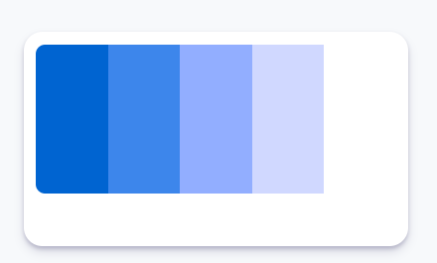sekunder

.color2 {color: #3d86eb;}

aksen

.color3 {color: #92aeff;}

Aksen

.color4 {color: #d0d8ff;}

Aksen

.color5 {color: #ffffff;}

primer